**Overview of the school district analysis**

I am being brought in as a data analyst to either give proof or disprove the ideal that test results from the 9th grade class at Thomas High School has been cheating on their exams. I will be comparing how removing the 9th grade class effects the overall results of the rest of the school. I have already found the overall passing percentage of the students. Now to find if there is any correlation to my findings and the budget per student.

* + **How is the district summary affected**?
    - There is not much deviation from the original data and to what was seen when data was cleaned up. Average scores in Reading and Math only changed by one percentage point while the overall passing percentage rose by one percent from 64 to 65%.

district_summary_b

With 9th

district_summary_a

Without 9th

* + **How is the school summary affected?**
* Thomas High School overall passing percent went from 90.95% to 65.08% after removing 9th grades testing results. That is a significant change in percentage when comparing with and without 9th graders. This leads to believe that the 9th grade class scores were dragging the overall scores down.

With 9th

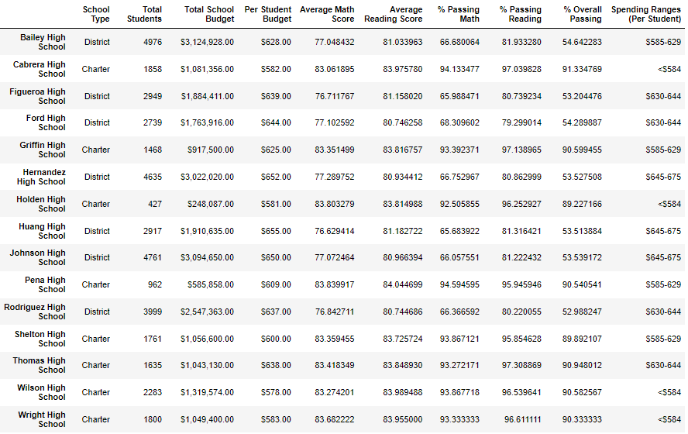

Without 9th

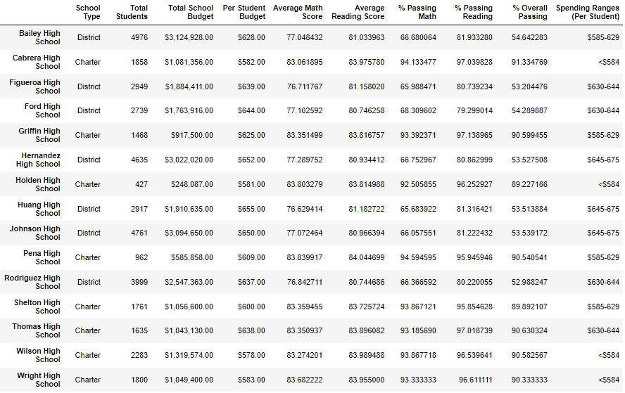

* **How does replacing the ninth graders math and reading scores affect Thomas High Schools performance relative to the other schools?**
* Thomas High School % passing math went from 66.91% up to 93% and as for reading the percentage went from 69.6% to 97% so relative to the other schools, they rose up to the top 3 in each category. While originally, they were middle of the pack.

The top performing schools and low performing schools after removing 9th

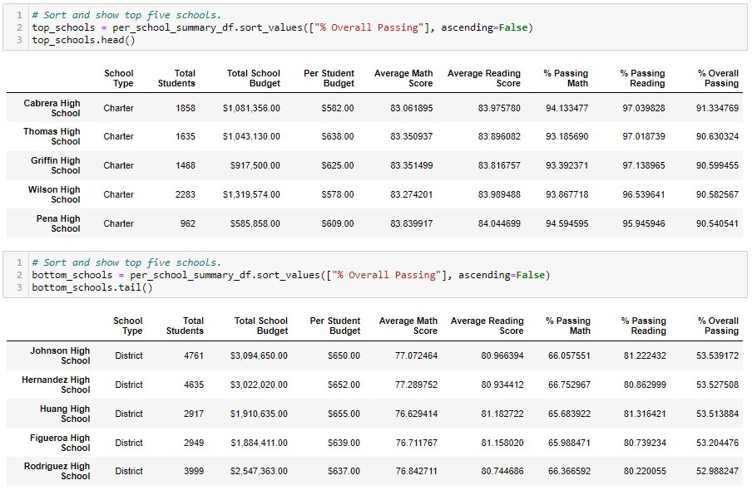

* Math and reading score by grade: Math grade for 9th graders went from 80.34% down to 80.12% and reading did not change much. Not much variance to be seen.

Math and Reading scores before

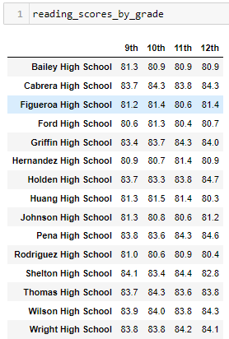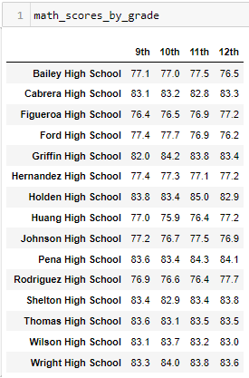

* Scores by school spending: Thomas High school was in the $630 to $644 spending range and was one of four high schools in that range, their % passing math was higher than average According to the dataframe there is a relationship with how much a school spends per student and having higher overall passing percentage. You can see the lowest passing percentage is the highest budget while the lowest budget has the highest passing percentage.

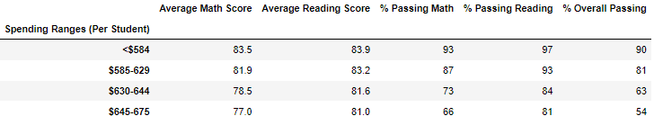

* Scores by school type: Thomas High school, as it is a charter school, negatively affected the passing math percentage and passing reading percentage. Looking at the schools as a whole Charter schools have outperformed the district schools by a large margin. Just comparing overall passing Charter is at 90 while you have 54 for the district schools.

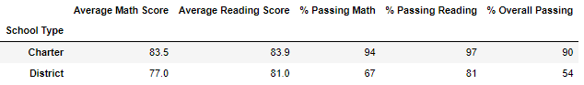

**Summary**

Overall, replacing all of Thomas High Schools 9th grade math and reading test results has increased since removing the data from all the 9th graders. This was also evident in the overall passing percentage. Looking at the data compiled by school type or size the removal didn’t play that much of an influence. Charter schools that didn’t spend a lot of money on their students did produce the best results. The main point of the analysis was to see if there was anything indicating that the 9th graders were involved in cheating at Thomas High. Looking at how their grades were dragging down the average I can not say the evidence points to cheating. Nothing is conclusive being that they are 14-15 year olds and could have easily cheated but still got a worse grade. The only thing I can say, without a doubt, is that the students did mess with the data of names to add humorous prefixes and suffixes.